**4.** **Spring Core – Load Country from Spring Configuration XML**

**//pom.xml**

<?xml version="1.0" encoding="UTF-8"?>

<project xmlns="http://maven.apache.org/POM/4.0.0" xmlns:xsi="http://www.w3.org/2001/XMLSchema-instance"

xsi:schemaLocation="http://maven.apache.org/POM/4.0.0 https://maven.apache.org/xsd/maven-4.0.0.xsd">

<modelVersion>4.0.0</modelVersion>

<parent>

<groupId>org.springframework.boot</groupId>

<artifactId>spring-boot-starter-parent</artifactId>

<version>3.5.3</version>

<relativePath/> <!-- lookup parent from repository -->

</parent>

<groupId>com.cognizant</groupId>

<artifactId>spring-learn</artifactId>

<version>0.0.1-SNAPSHOT</version>

<name>spring-learn</name>

<description>Demo project for Spring Boot</description>

<url/>

<licenses>

<license/>

</licenses>

<developers>

<developer/>

</developers>

<scm>

<connection/>

<developerConnection/>

<tag/>

<url/>

</scm>

<properties>

<java.version>21</java.version>

</properties>

<dependencies>

<dependency>

<groupId>org.springframework.boot</groupId>

<artifactId>spring-boot-starter-web</artifactId>

</dependency>

<dependency>

<groupId>org.springframework.boot</groupId>

<artifactId>spring-boot-devtools</artifactId>

<scope>runtime</scope>

<optional>true</optional>

</dependency>

<dependency>

<groupId>org.springframework.boot</groupId>

<artifactId>spring-boot-starter-test</artifactId>

<scope>test</scope>

</dependency>

<dependency>

<groupId>org.springframework</groupId>

<artifactId>spring-context</artifactId>

</dependency>

<dependency>

<groupId>org.slf4j</groupId>

<artifactId>slf4j-api</artifactId>

</dependency>

</dependencies>

<build>

<plugins>

<plugin>

<groupId>org.springframework.boot</groupId>

<artifactId>spring-boot-maven-plugin</artifactId>

</plugin>

</plugins>

</build>

</project>

**//country.xml**

<?xml version="1.0" encoding="UTF-8"?>

<beans xmlns="http://www.springframework.org/schema/beans"

xmlns:xsi="http://www.w3.org/2001/XMLSchema-instance"

xsi:schemaLocation="http://www.springframework.org/schema/beans

https://www.springframework.org/schema/beans/spring-beans.xsd">

<bean id="country" class="com.cognizant.spring_learn.Country">

<property name="code" value="IN" />

<property name="name" value="India" />

</bean>

</beans>

**// Country.java**

package com.cognizant.spring_learn;

import org.slf4j.Logger;

import org.slf4j.LoggerFactory;

class Country {

private static final Logger ***LOGGER*** = LoggerFactory.*getLogger*(Country.class);

private String code;

private String name;

public Country() {

***LOGGER***.debug("Inside Country Constructor.");

}

public String getCode() {

***LOGGER***.debug("Getting code: {}", code);

return code;

}

public void setCode(String code) {

***LOGGER***.debug("Setting code: {}", code);

this.code = code;

}

public String getName() {

***LOGGER***.debug("Getting name: {}", name);

return name;

}

public void setName(String name) {

***LOGGER***.debug("Setting name: {}", name);

this.name = name;

}

*@Override*

public String toString() {

return "Country [code=" + code + ", name=" + name + "]";

}

}

**//SpringLearnApplication.java**

package com.cognizant.spring_learn;

import org.slf4j.LoggerFactory;

import org.springframework.boot.autoconfigure.SpringBootApplication;

import org.slf4j.Logger;

import org.springframework.context.ApplicationContext;

import org.springframework.context.support.ClassPathXmlApplicationContext;

@SpringBootApplication

public class SpringLearnApplication {

private static final Logger LOGGER = LoggerFactory.getLogger(SpringLearnApplication.class);

public static void main(String[] args) {

LOGGER.info("START");

displayCountry();

LOGGER.info("END");

}

public static void displayCountry() {

ApplicationContext context = new ClassPathXmlApplicationContext("country.xml");

Country country = (Country) context.getBean("country", Country.class);

LOGGER.info("Country : {}", country.toString());

}

**Output:**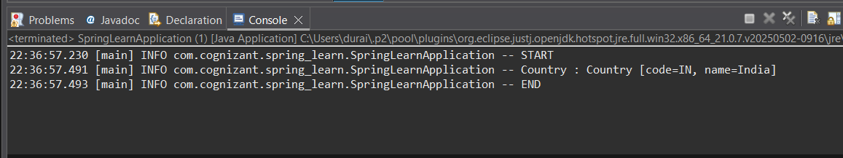

**SME:**

| **Element** | **Meaning** |
| --- | --- |
| <bean> | Declares a Spring-managed object |
| id | Unique ID used to retrieve the bean |
| class | Fully qualified name of the bean class |
| <property> | Sets a field of the bean |
| name | Name of the property in the Java class |
| value | Value to inject |

ApplicationContext is the main interface for Spring’s IoC container.

ClassPathXmlApplicationContext loads XML config files from the classpath.

**What happens during context.getBean("country"):**

* Spring parses country.xml.
* It creates the Country bean using the default constructor.
* It injects code and name properties.
* Returns the fully initialized bean.